Organized by
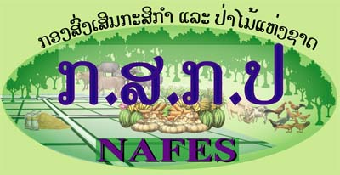 | 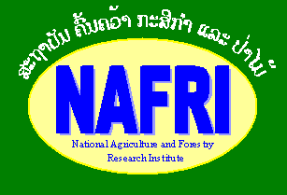 | 
Registration form for the workshop on
Connecting the last mile: best practices in rural communication
July 31 – August 1

Please fill out for each person interested to attend and return:
Email: ruralcom@nafri.org.la and linkages@laoex.org
Or contact
Mr. Bandith Ramangkoun | Head of Information Services Unit, NAFRI | Tel: 221-1317  Email: bandith@nafri.org.la
Mr. Phoutthasinh Phimmachanh | Knowledge Management Officer, NAFES/LEAP | Tel: 561-1716  Email: linkages@laoexorg
Mr. Hongthong Sirivath | National Program Officer, Village Focus International | Tel: 549-9095  Email: Hongthong@villagefocus.org
Michael Victor | Information Service Adviser, NAFRI | Tel: 552-6693  Email: omichael@loxinfo.co.th

Remark:

Each participant from INGOs, NPA, and donor agency should pay $25 for registration in the morning of July 31, 2007 (during the registration hour). The fee will cover for all materials distributing at the workshop (including 1 GB thumb drive) and food.

A. General information
1. Name
2. Position:
3. Office/Organization:
4. Address:
5. Province
6. Tel: (mobile/regular)
7. E-mail:

B. Comments on workshop note and expectations

8. What do you expect to get out of the workshop?

9. What would you like the workshop to focus on and/or what are missing elements in the current workshop concept note

C. Contributions to the workshop
10. What are you interested to contribute

10.1 Presentation: Yes (if yes, see 11) No

10.2 Poster/display/materials at information market: Yes No

Bottom of Form

11. If you would like to make a presentation, please send us information and include a description of the following (no more than a page):
- What activities are you currently carrying out in terms of rural communication and dissemination?
- What key issues will your presentation/experience address (based on issues described in note)
- Briefly describe what approaches and tools do you use for:
- Generating content
- Delivering information:
- Getting feedback from users
- What are the key lessons and/or results you have had?
D. Other contributions
12. What other contributions can your organization/project make to the workshop (support to provincial, district or village participants to attend, etc.)?

13. What information does your organization produce which could be adapted, repackaged or used by farmer’s or farmers’ groups?

